pandas基础应用01 DataFrame read_csv
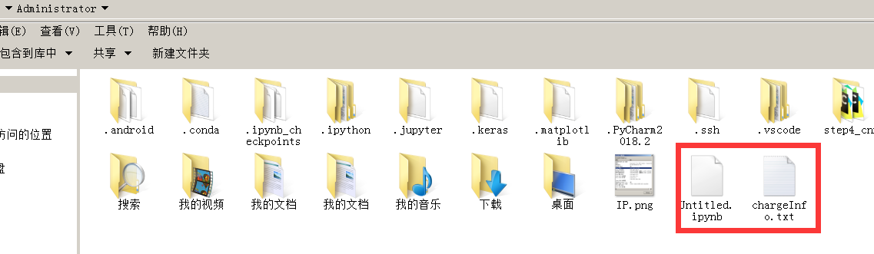
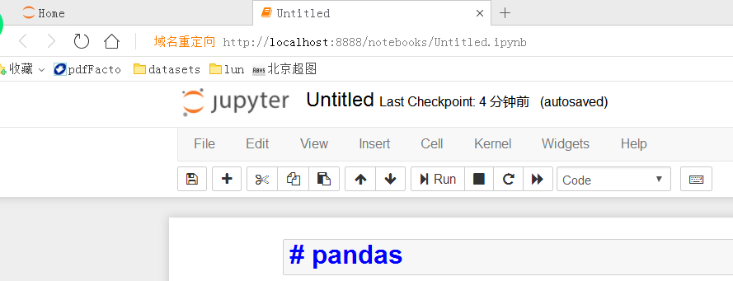
pd.DataFrame
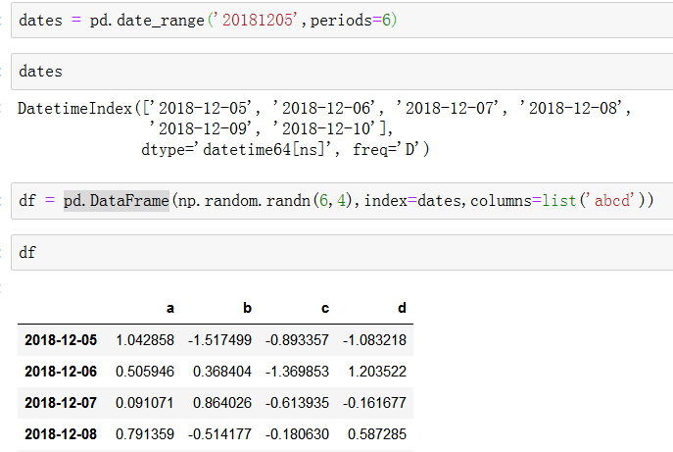
pd.read_csv
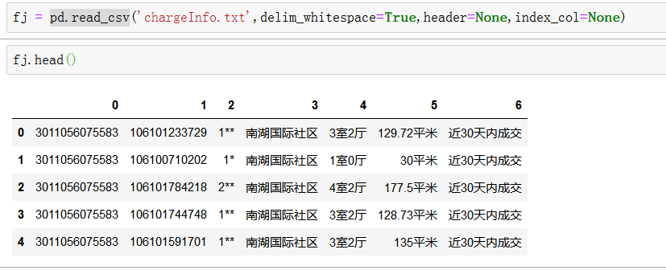

参考：
https://www.cnblogs.com/datablog/p/6127000.html

